**IN MEMORIAM**

**DR KATHY EVANS**

With great sadness we announce the passing away from cancer of our dear friend and colleague, Dr Kathy Evans, at l'Hôpital de Bergerac, France, in October 2024.  Kathy was actively involved in ENSEC from its very first conference in Malta in 2007 right up to the 2024 conference in Chania, Greece. We were joint ENSEC Chairs for 6 years from 2011-2017 during which time Kathy took her role very seriously and was a constant source of creative ideas.

**Kathy with Carmen and Renata**

We will never forget her enthusiasm for ENSEC and her deep commitment to the emotional health and wellbeing of children.  Kathy integrated her many roles as parent, foster parent, partner, grandmother, teacher in special education schools, researcher, author and Course Director at the University of South Wales *MA in Child and Adolescent Mental Health.* She was full of practical ideas to help parents and caregivers meet the challenge of rearing children.  In *Supporting Parental Wellbeing*, co-authored with Rob Long, she recommended that parents take account of their own wellbeing and offered wise guidance on ways of strengthening it to develop positive relationships with their children.  Another book, *Supporting Children at Home*, also co-authored with Rob Long, was a lifeline for parents during the stressful COVID pandemic lockdown period.   She and Rob recognised the huge pressures on parents whether they were in lockdown with their children all day or whether they were separated from them because they were essential keyworkers. This book contained myriad activities for stimulating children at home through art, stories, music and drama.

**Kathy after her PhD viva**

She was committed to the work of ENSEC to the end and, although she was too ill to attend, wrote a paper for a symposium at the 2024 ENSEC conference in Chania, Crete, based on her chapter, with Lynn Gazal, *Interventions to challenge cyberbullying and online harassment: the perspective from schools* (in *Cyberbullying and Online Harms,* edited by Helen Cowie and Carrie-Anne Myers), which was published in 2023.  Her imaginative paper was presented by Lynn Gazal to an appreciative audience.  How we wished that she could have been there in person!

Kathy loved her house in France and often invited friends to stay.

**Kathy outside her house in France**

In fact, the 2013 ENSEC conference in Zagreb was planned and prepared from there.  We remember her quiet way of working collaboratively with us all, gently inserting her practicality, enormous knowledge and vision into the process.

**Kathy giving her lecture at the Zagreb conference**

We all have memories of spending special times with her in the beautiful places where we held the conferences, having all kinds of conversations which ranged seamlessly around the academic, the practical and the personal.  We remember reflections on our lovely surroundings as we walked, drank coffee and often had just plain good fun.  She was wonderful company, and she became a dear, kind and compassionate friend.

Kathy was courageous in her fight against cancer. When it returned, she asked us to help her sift through the research literature on new cancer treatments. Here is one of her messages to us:

“Love you all :-) And one thing actually you can do for me if you get time - given you are all researchers - is when I confirm the type of cancer - you can help me research new and amazing treatments.  I've decided to become an expert on it as one way forward. Kathy xxxx”

Kathy was such a fighter!

Right to the end of her life Kathy demonstrated her kindness to others. She insisted on sharing her hospital food – yogurts and fruit – with the close friends and her partner, Bruno, who were by her bedside in her final days. It was very important to her that they all sat and ate together. Perhaps even more poignant was her tolerance and kindness to the old men with dementia in the next room. One kept banging repetitively on the wall with a stick but Kathy never complained. The other one burst into her room one day and, while her friends assertively told him to leave, Kathy jumped to his defence and spoke to him in a soft reassuring way.

**Kathy relaxing with Carmen and Renata**

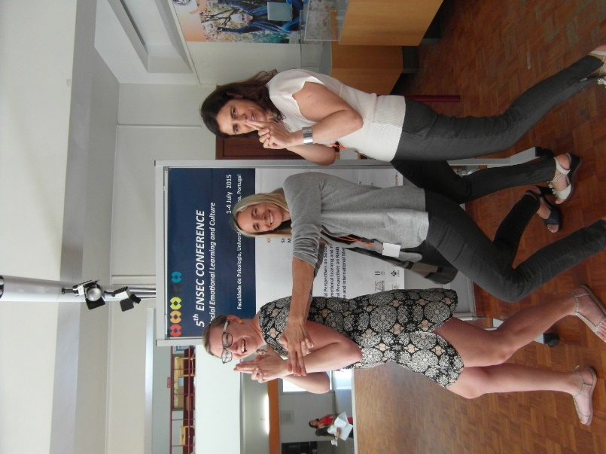

**Having fun with Carmen and Celeste**



**Kathy with the ENSEC Chairs during the fourth ENSEC Conference at the University of Zagreb, Croatia, 2013 from left to right Paul Cooper, Carmen Huser, Carmel Cefai, Helen Cowie, Katherine Weare, Kathy Evans, Renata Miljević-Riđički**  **(Celeste Simões took the photo)**

Although Kathy is no longer with us, we still have many fond memories of her.  We will never forget our dear friend.

Carmel, Carmen, Celeste, Helen, Katherine, Paul, Renata (former ENSEC Chairs)